Fake News Detection Using AI
Design Document

Version 1.0



Group Id: F25PROJECTB0FB6
Supervisor Name: Huma Mumtaz
Studen Name: Muhammad Tayyar Hussain
VU Id: BC220201723

Revision History
Date (dd/mm/yyyy) | Version | Description | Author
28 / 11 / 2025 | 1.0 | Introduction | BC220201723

Table of Contents

- Introduction of Design Document
- Entity Relationship Diagram (ERD)
- Sequence Diagrams
- Architecture Design Diagram
- Class Diagram
- Database Design
- Interface Design
- Test Cases

Introduction of Design Document:
The software design document describes the detailed system design of the Fake News Detection
System, which was earlier mentioned in the SRS document. The main purpose of this document is to translate user requirements into a well-defined technical plan, which will be used as a blueprint during the implementation/coding phase.
This document includes:

- An Entity Relationship Diagram (ERD) is used to model the system data structure.
- Sequence diagrams to show the interaction between actors and different components of the system,
- A tiered architecture design diagram to show how the overall bigger components of the system are organized and their physical and logical partitioning.
- A class diagram to define smaller system components and abstract entities from which instances of different classes are realized.
- A database design diagram to define the actual tables in the DBMS system.
- Interface designs (GUI) to visualize how the user will interact with the most important parts of the system.
- Test cases to validate and verify each use case scenario that was defined in the SRS document.

The design phase plays a very big part in the entire software development life cycle because it ensures that the system components are logically well defined, technically feasible, and properly aligned with user requirements before actual coding begins.

By identifying the system entities, their relationships, and architectural layers at this stage, the risk of introduction of major errors or defects is significantly reduced, making the system development easier and easier to maintain, and indirectly the cost of development is reduced.

For this project, the design phase is critically important because it integrates machine learning models with a web application. It will also ensure that all system components are clearly defined and properly connected with each other.

Overall, this Design Document serves as a reference point for developers, testers, and project managers, ensuring consistency between the SRS and the final implemented system while improving maintainability and other non-functional requirements.

Entity Relationship Diagram (ERD):
Please zoom in to clearly see it!
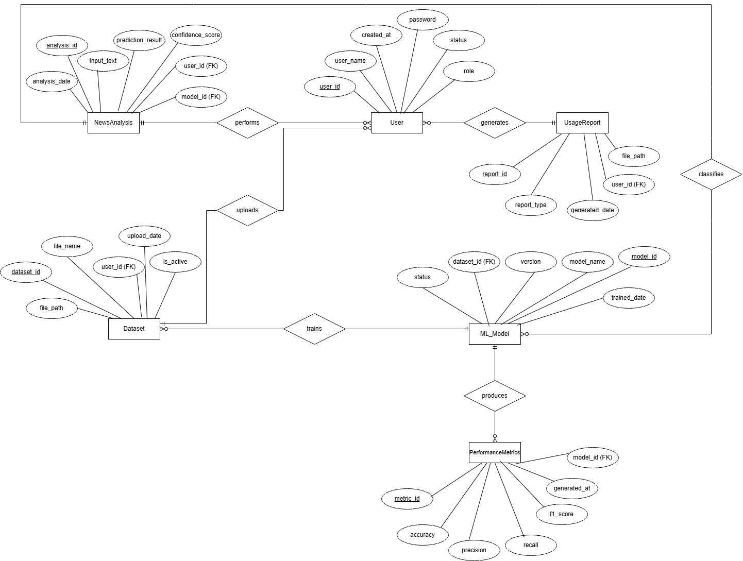

Sequence Diagrams:
Sequence diagram of UC-01 Manage user accounts
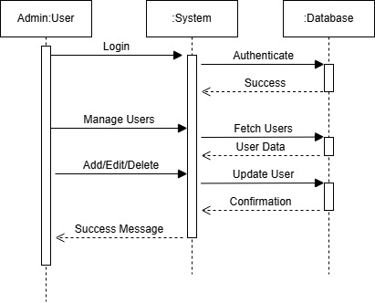

Sequence diagram of UC-02 Upload new dataset
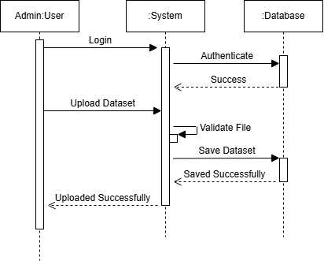

Sequence diagram of UC-03 Retrain the ML model
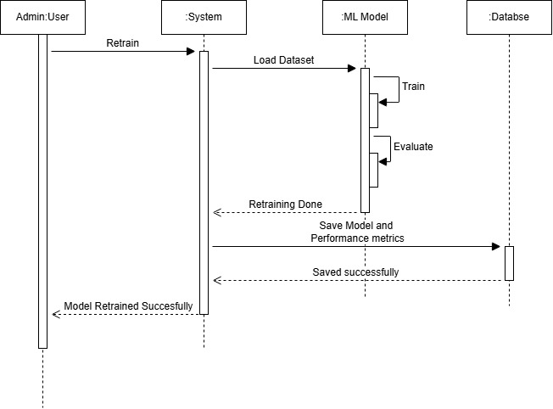
Sequence diagram of UC-04 View overall system performance metrics
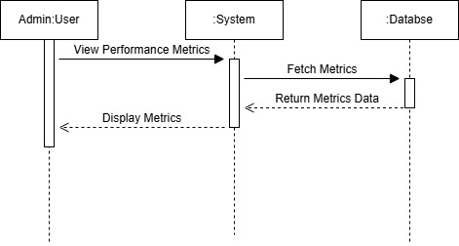

Sequence diagram of UC-05 Generate system usage reports
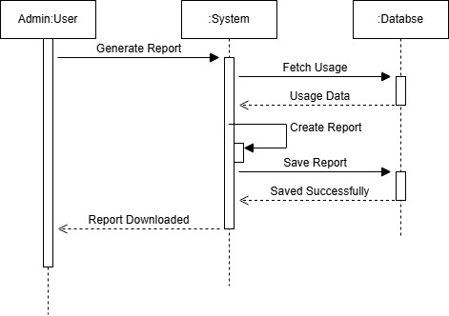

Sequence diagram of UC-06 Manage and Delete user analyzed history
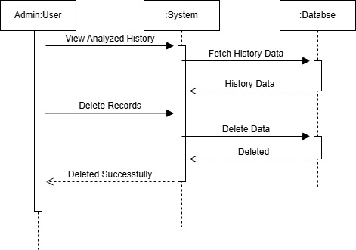

Sequence diagram of UC-07 Register account
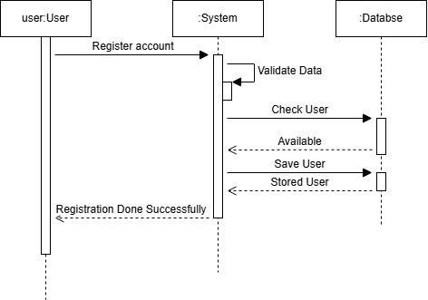

Sequence diagram of UC-08 Login
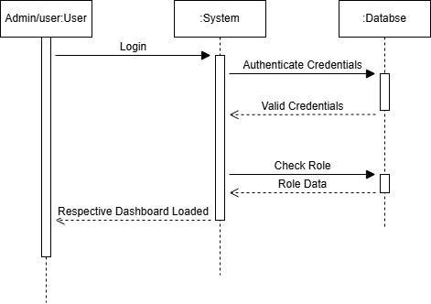

Sequence diagram of UC-09 Input article/headline for analysis
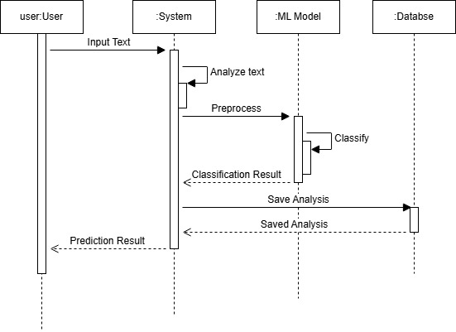

Sequence diagram of UC-10 View classification results
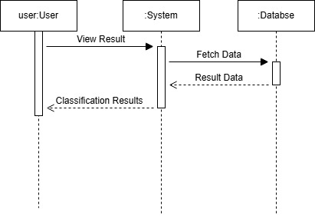

Sequence diagram of UC-11 View history of their analysis
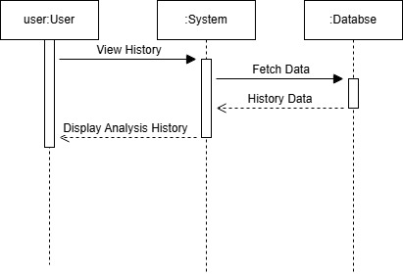

Sequence diagram of UC-12 Use sample text for analysis
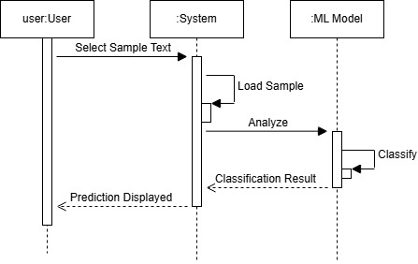

Sequence diagram of UC-13 View graphs of their analysis
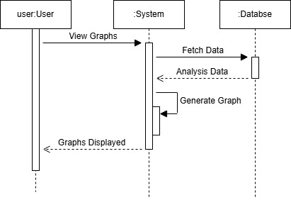

Sequence diagram of UC-14 Export classification results
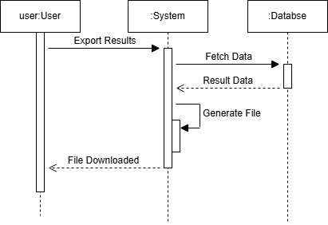

Architecture Design Diagram:
Please zoom in to clearly see it!
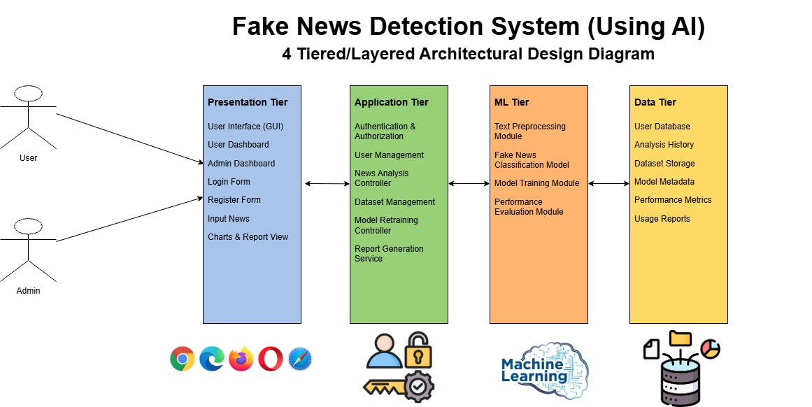
Database Design Diagram:
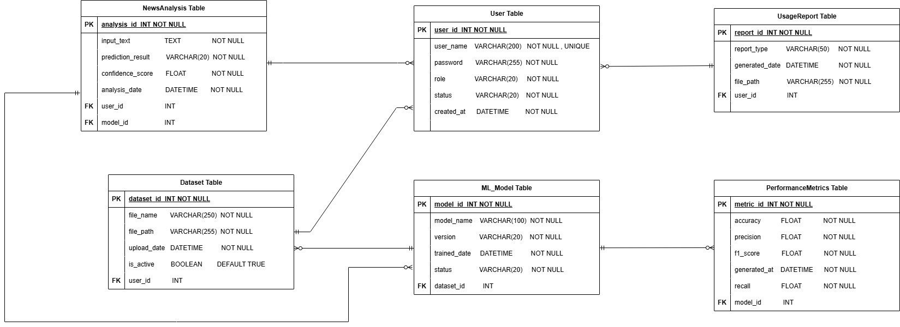
Please zoom in to clearly see it!
Class Diagram:
Please zoom in to clearly see it!
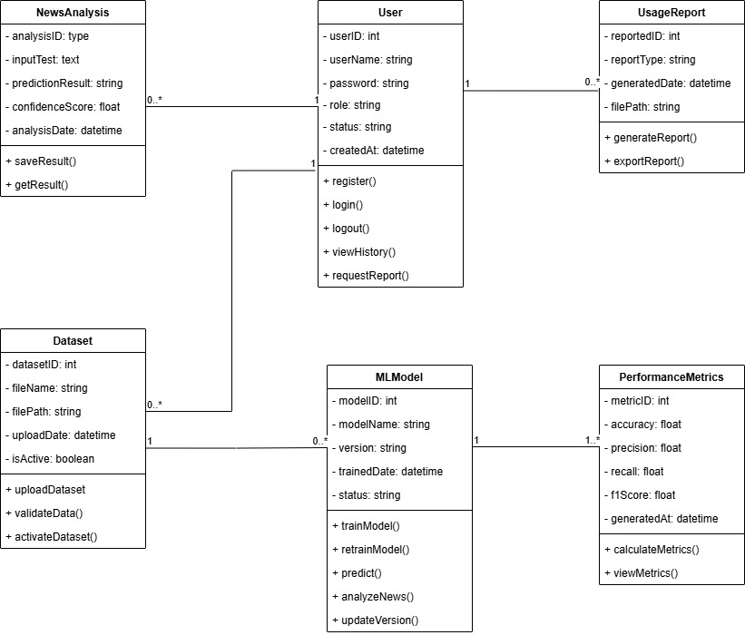

Interface Designs (GUI):
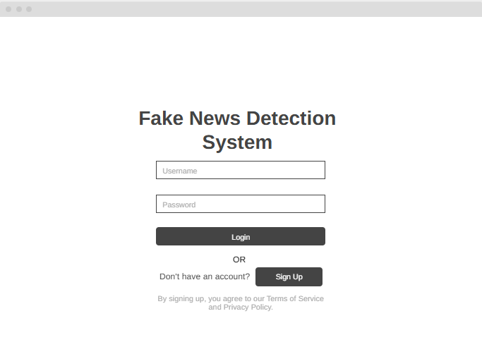
Login page

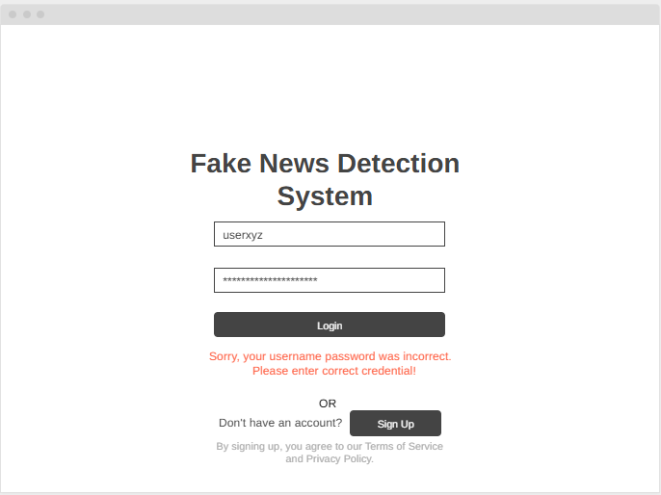
Login page (if user entered wrong credentials)

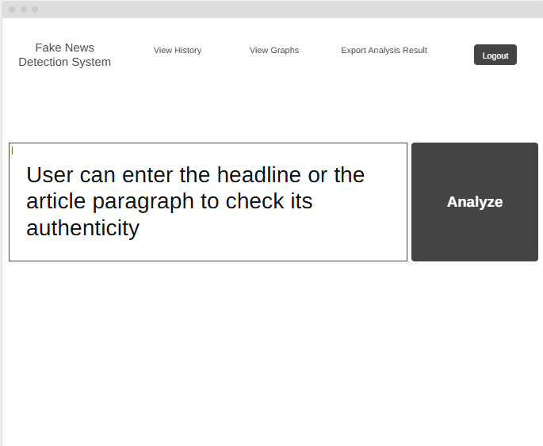
User Panel dashboard

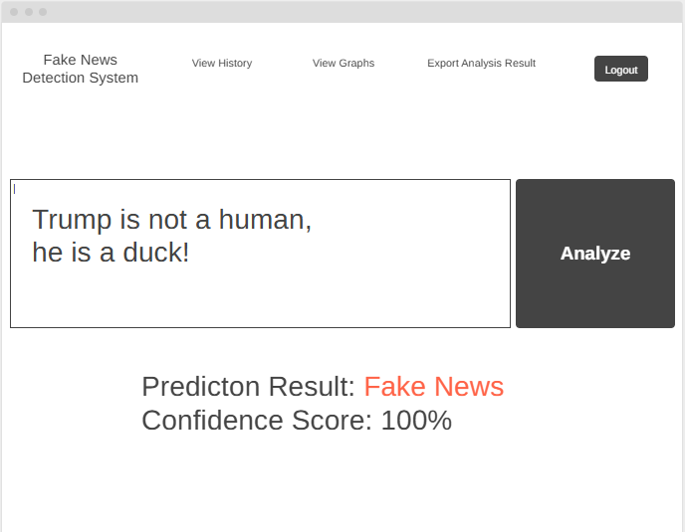
User panel when user enters a fake news.

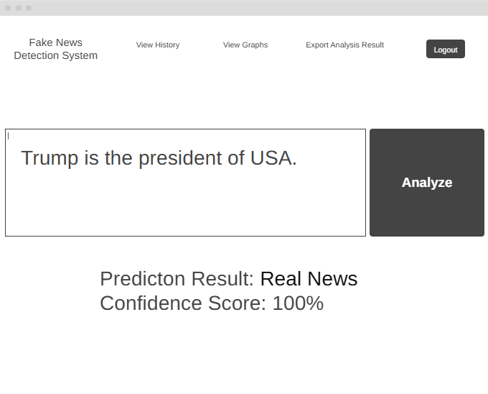
User panel when user enters a Real news

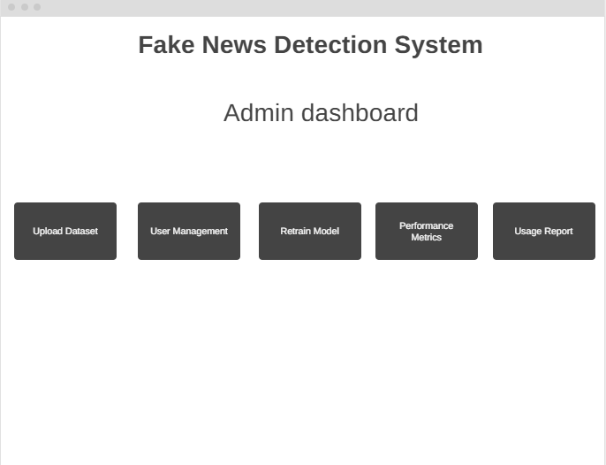
Admin Panel dashboard (admin can perform the different functionalities by clicking on the buttons).

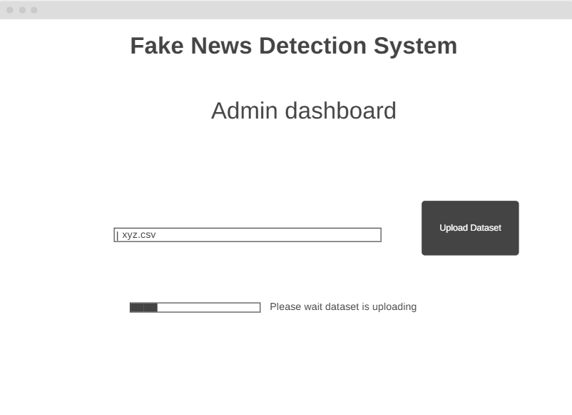
Admin is performing the uploading data functionality of the system.

Test Cases:
These test cases were designed for each usage scenario to verify the system functionality.
Test Case ID | TC-01
Use Case ID | UC-01: Manage user accounts
Actor | Admin
Precondition | Admin must be logged in first in the system
Test Steps: | - Navigate to Manage User Accounts  - Add/Edit/Delete a user.  - Save changes
Expected Result | User account is added, updated or deleted successfully
Alternative Result | Error message is shown if user already exists in the system.
Status | Pass/Fail
Author | Muhammad Tayyar Hussain BC220201723

Test Case ID | TC-02
Use Case ID | UC-02: Upload new dataset
Actor | Admin
Precondition | Admin must be logged in first in the system.
Test Steps: | - Select a CSV file.  - Click on Upload dataset button.
Expected Result | Dataset uploaded and stored successfully
Alternative Result | Error message is shown for Non-CSV file.
Status | Pass/Fail
Author | Muhammad Tayyar Hussain BC220201723

Test Case ID | TC-03
Use Case ID | UC-03: Retrain the ML model
Actor | Admin
Precondition | Dataset exists in the system.
Test Steps: | - Click on Retrain Model button.  - Wait for completion of the model
Expected Result | Model is retrained successfully and performance metrics are updated
Alternative Result | Error message is shown if retraining fails
Status | Pass/Fail
Author | Muhammad Tayyar Hussain BC220201723

Test Case ID | TC-04
Use Case ID | UC-04: View overall system performance metrics
Actor | Admin
Precondition | Trained model should exist in the system.
Test Steps: | - Click on Performance Metrics page/button.
Expected Result | Accuracy, Precision, Recall, F1-Score are displayed.
Alternative Result | No performance data is available to show
Status | Pass/Fail
Author | Muhammad Tayyar Hussain BC220201723

Test Case ID | TC-05
Use Case ID | UC-05: Generate system usage reports
Actor | Admin
Precondition | System usage data should exist in the system.
Test Steps: | - Click on system usage report page/button  - Click on export report.
Expected Result | CSV report downloaded successfully
Alternative Result | Error message is shown if exports fails.
Status | Pass/Fail
Author | Muhammad Tayyar Hussain BC220201723

Test Case ID | TC-06
Use Case ID | UC-06: Manage and Delete user analyzed history
Actor | Admin
Precondition | User history data should exist in the system.
Test Steps: | - Click to select few history entries  - Click on delete button
Expected Result | User history deleted successfully
Alternative Result | Deletion canceled by the admin
Status | Pass/Fail
Author | Muhammad Tayyar Hussain BC220201723

Test Case ID | TC-07
Use Case ID | UC-07: Register account
Actor | User
Precondition | Username is not already taken in the system.
Test Steps: | - Click to enter a username  - Click on enter a password  - Click on Register account button.
Expected Result | User account created successfully.
Alternative Result | Error message shown if password is weak.
Status | Pass/Fail
Author | Muhammad Tayyar Hussain BC220201723

Test Case ID | TC-08
Use Case ID | UC-08: Login
Actor | User/Admin
Precondition | User/Admin account exists in the system.
Test Steps: | - Click to enter a username  - Click on enter a password  - Click on Login button.
Expected Result | User/Admin respective dashboard is loaded
Alternative Result | Error message shown if incorrect credentials are entered
Status | Pass/Fail
Author | Muhammad Tayyar Hussain BC220201723

Test Case ID | TC-09
Use Case ID | UC-09: Input article/headline for analysis
Actor | User
Precondition | User must be logged in first in the system.
Test Steps: | - Click to enter text.  - Click on Analyze button.
Expected Result | User entered text process successfully.
Alternative Result | Error message shown if no text is given or too short for input processing.
Status | Pass/Fail
Author | Muhammad Tayyar Hussain BC220201723

Test Case ID | TC-10
Use Case ID | UC-10: View classification results
Actor | User
Precondition | News analysis completed
Test Steps: | - Click on view classification result page.
Expected Result | Result of news either Real/Fake with its confidence score.
Alternative Result | A message is shown No result available.
Status | Pass/Fail
Author | Muhammad Tayyar Hussain BC220201723

Test Case ID | TC-11
Use Case ID | UC-11: View history of their analysis
Actor | User
Precondition | User history data should exist in the system.
Test Steps: | - Click on view history button.
Expected Result | Result of past analysis is displayed.
Alternative Result | A message is shown No history is available to show.
Status | Pass/Fail
Author | Muhammad Tayyar Hussain BC220201723

Test Case ID | TC-12
Use Case ID | UC-12: Use sample text for analysis
Actor | User
Precondition | Sample text/data should exist in the system.
Test Steps: | - Click on use sample text button.  - Click on Analyze button.
Expected Result | Result of prediction is shown.
Alternative Result | A message is shown No sample text/date is available.
Status | Pass/Fail
Author | Muhammad Tayyar Hussain BC220201723

Test Case ID | TC-13
Use Case ID | UC-13: View graphs of their analysis
Actor | User
Precondition | At least one analysis result should exist in the system.
Test Steps: | - Click on view graphs button.
Expected Result | Graphs/Charts are shown.
Alternative Result | A message is shown No data is available to shown graph/chart.
Status | Pass/Fail
Author | Muhammad Tayyar Hussain BC220201723

Test Case ID | TC-14
Use Case ID | UC-14: Export classification results
Actor | User
Precondition | Analysis result should exist in the system.
Test Steps: | - Click on Export classification results button.
Expected Result | File downloaded successfully.
Alternative Result | Export canceled or failed.
Status | Pass/Fail
Author | Muhammad Tayyar Hussain BC220201723

